**ALUMNI**

1. Aditya Parashar, Mechanical ‘18, Currently working corporate in Hyderabad, 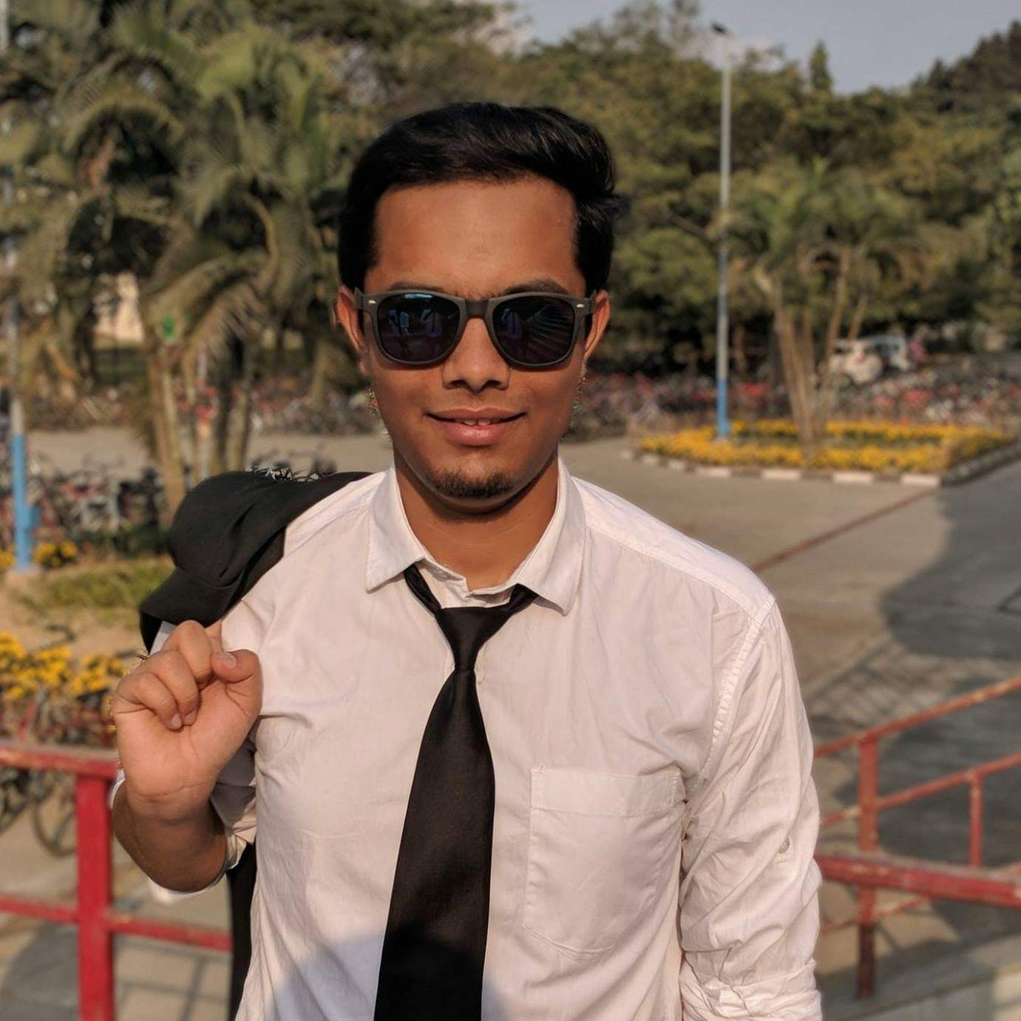

2. Yash Pote, CSE ‘18, Currently a research scholar in NUS

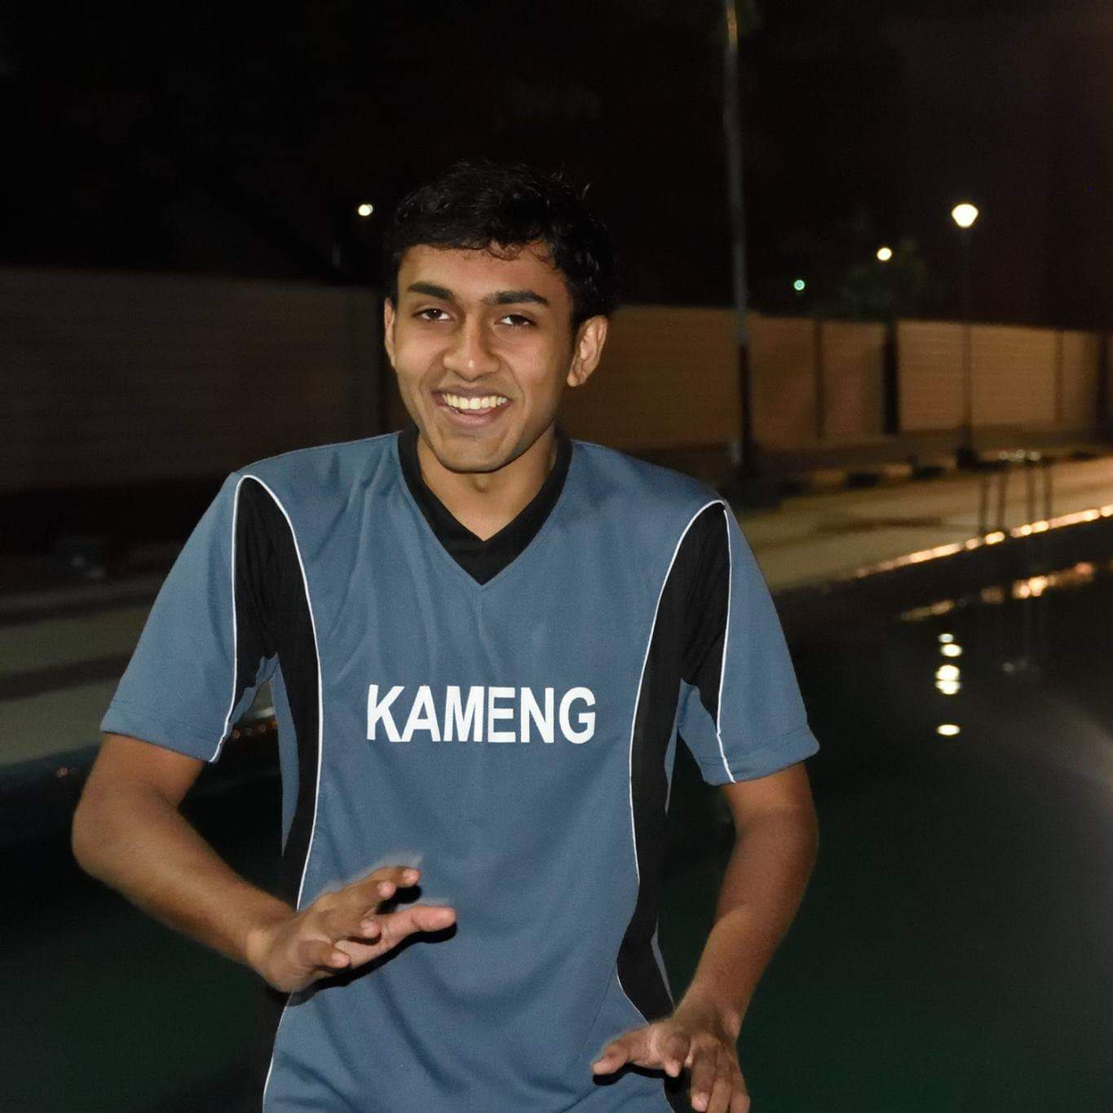

3. Dhrubojit Bhattacharya, ECE ‘18, Currently working at SAP labs Bangalore

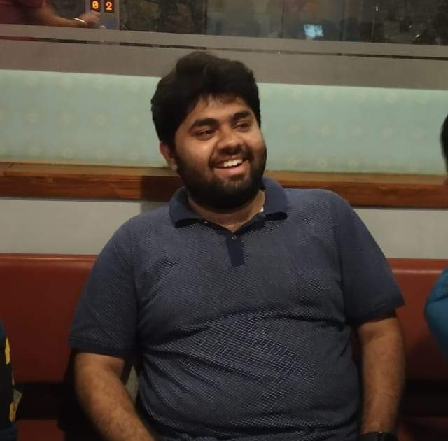

4. Aditya Prabhu, MnC ‘17, Currently working at Goldman Sachs Bangalore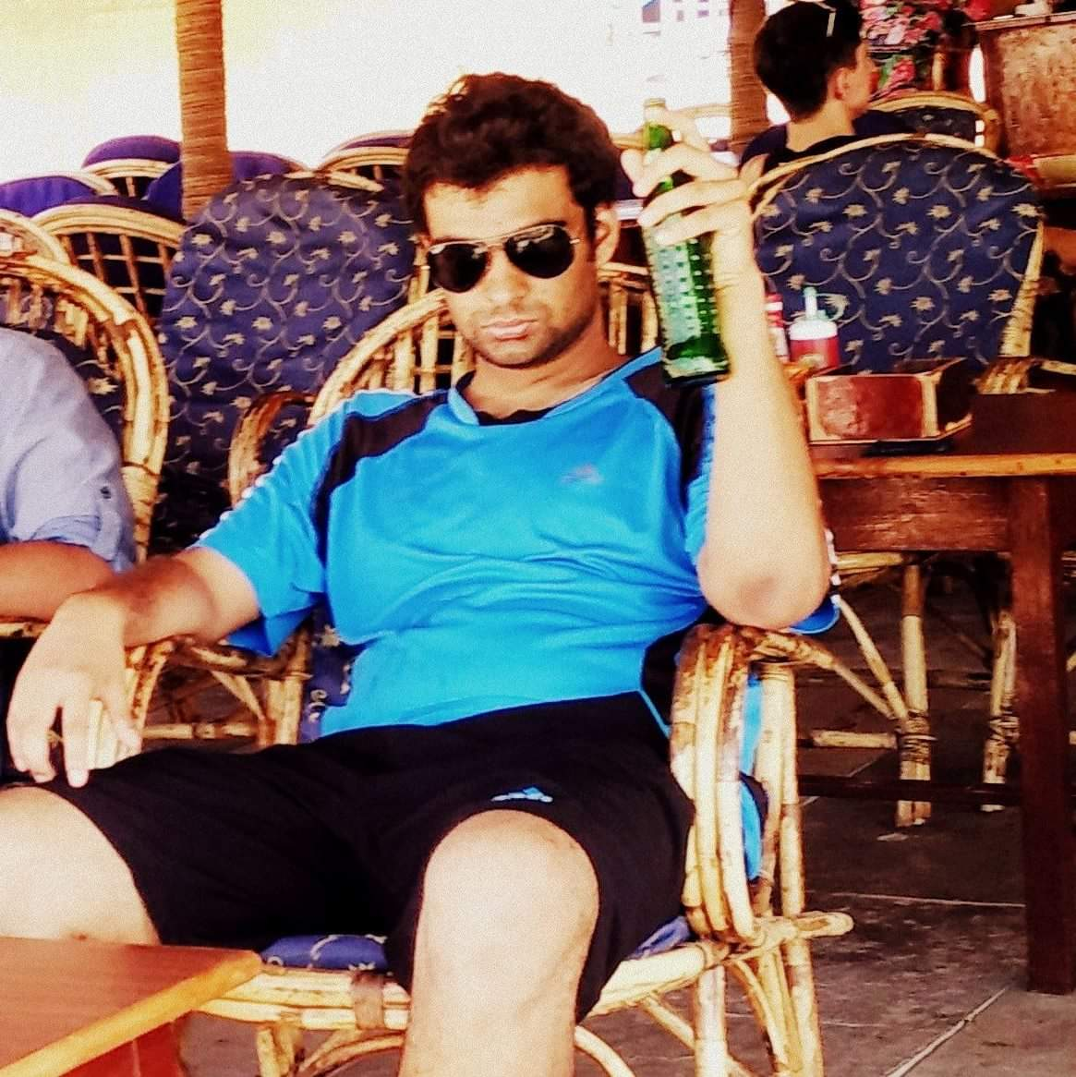

5. Prateek Raisinghani, CSE ‘17, Currently working in Goldman Sachs Bangalore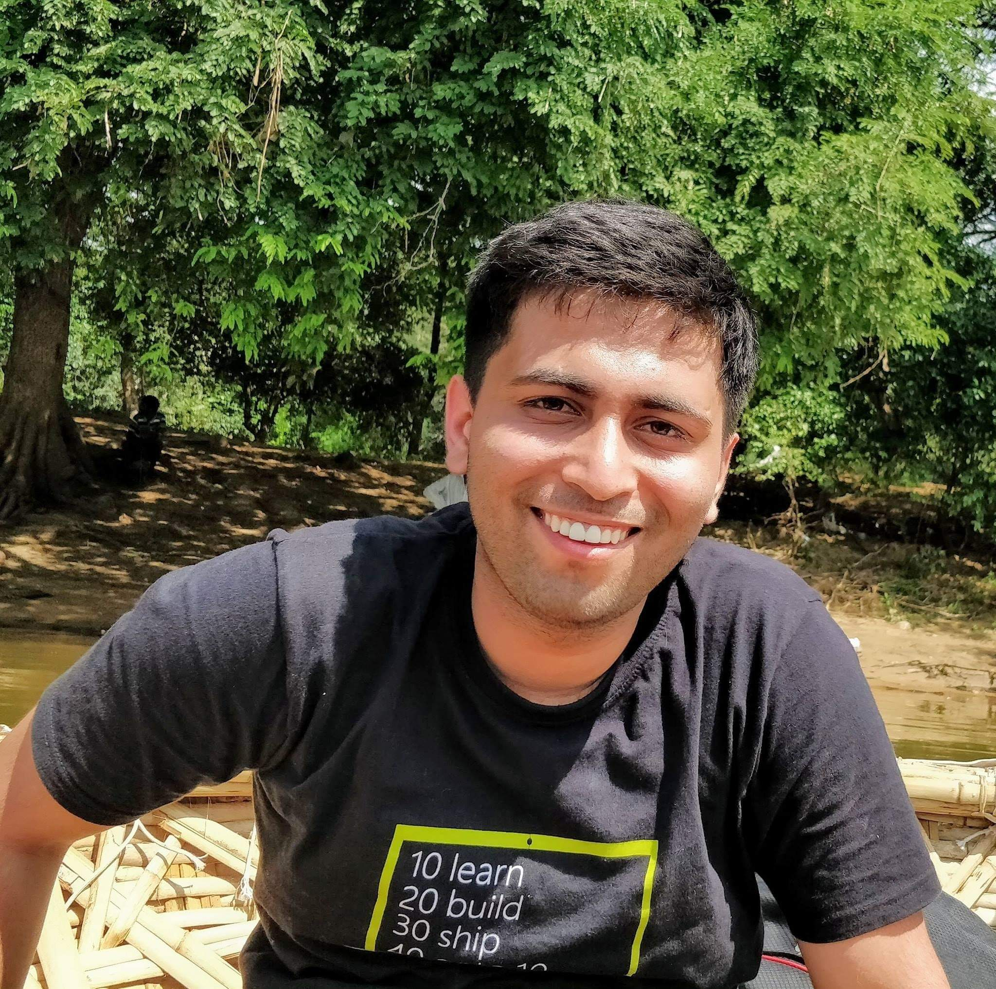

**CORE TEAM**

1. Rishabh Jain, Events Head, CSE 160101088, rishabh_jain, Umiam, 8901365438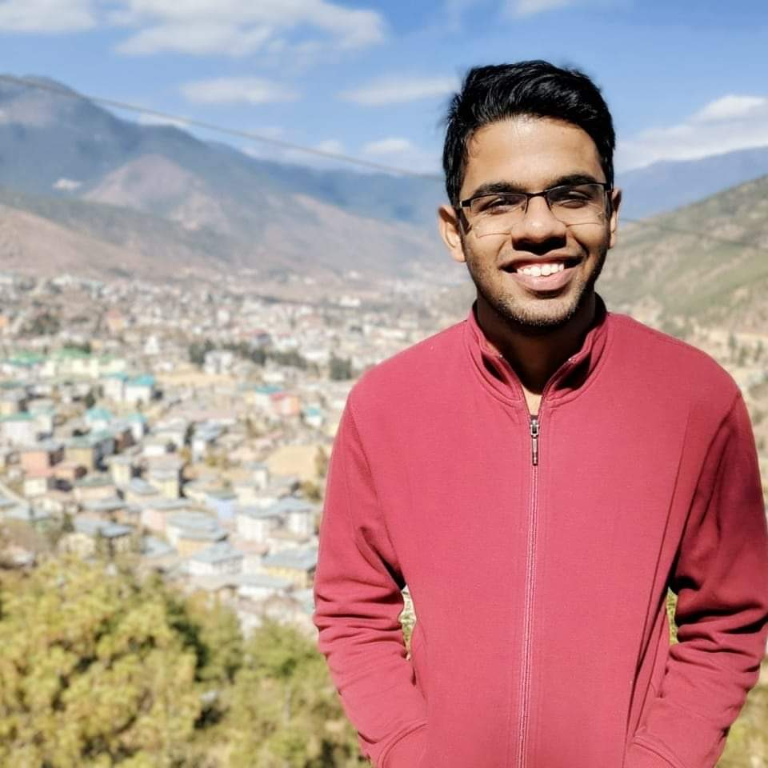

2. Sagar Mewar, Content head, MnC 160123034, sagar.mewar, Umiam, 9957994075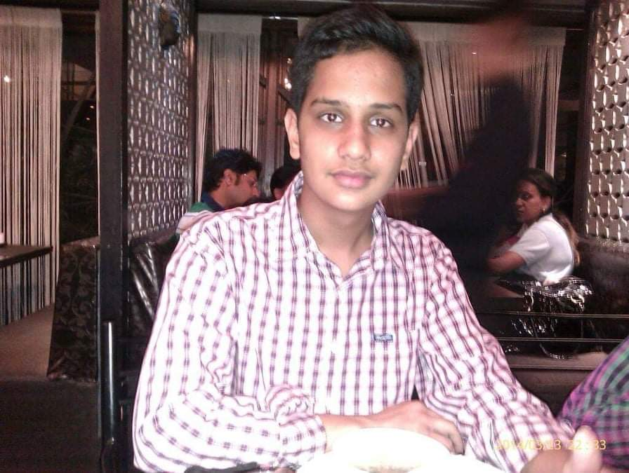

3. Sidharth Prateep, Design Head, Design 160205039, sidharth.p, Dihing, 7086686143